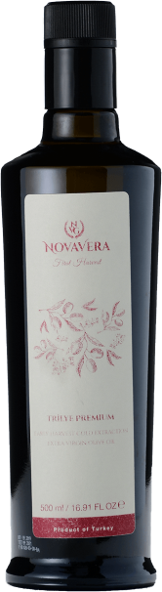**Nova Vera Wins Again**

Nova Vera won three Gold Awards at the 2020 NYIOOC World Olive Oil Competition.

This was the company's third consecutive year as an award recipient in the world's most prestigious olive oil quality contest, bringing the Turkish producer's all-time wins to six.

*We are proud to have won three Gold Awards in this prestigious competition. We have been milling rare local olive varieties of Turkey, such as Beylik and Hayat, and are excited to receive the encouraging results. We would like to thank the organizers and the jury for their efforts in creating this opportunity, despite the challenging circumstances.*

*Bahar Alan, Owner, Nova Vera*

The company produces extra virgin olive oil in Turkey from 50,000 Memecik, Beylik and Trilye olives using traditional harvesting methods.

Unusual weather patterns presented challenges during the season, owner Bahar Alan said when learning of the win today.

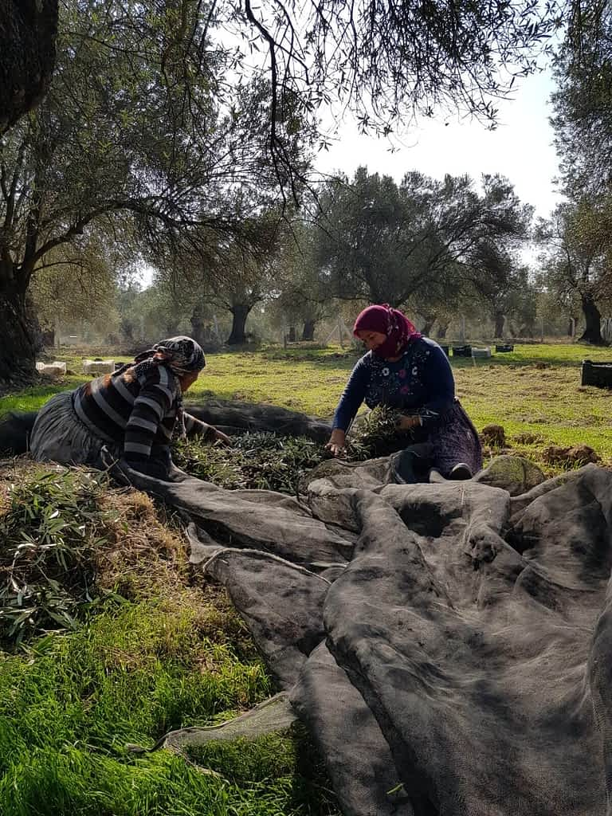

"In 2019 the groves located in the southern parts of Turkey were more productive, whereas the North Aegean parts of Turkey -- where our groves are located -- suffered strong rain and high heat during the blooming period, which led to serious production losses," Alan said. "Yet, one good thing about this season was that the olive quality was much better,"

The winning oils were: Nova Vera Hayat, a medium Memcik; Nova Vera Beylik, a medium Beylik; and Nova Vera Erken Hasat, a medium-intensity Trilye.

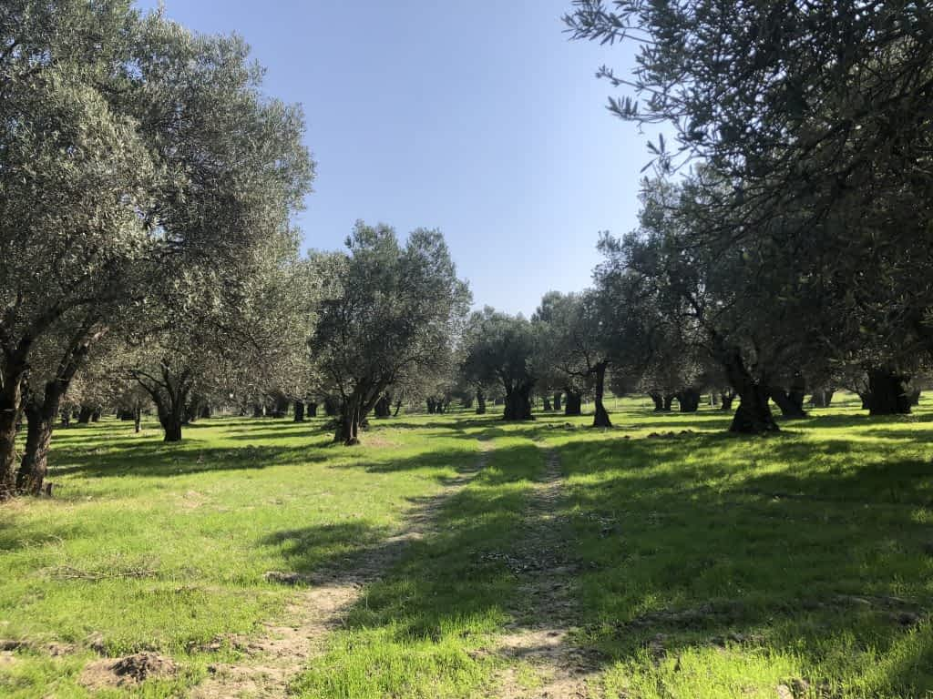

"We are proud to have won three Gold Awards in this prestigious competition. We have been milling rare local olive varieties of Turkey, such as Beylik and Hayat, and are excited to receive the encouraging results. We would like to thank the organizers and the jury for their efforts in creating this opportunity, despite the challenging circumstances," Alan said.

The NYIOOC World Olive Oil Competition, held each spring in New York, is the world's largest and most prestigious olive oil contest and its annual listing of award winners is considered the authoritative guide to the year’s best extra virgin olive oils.

The complete list of winners can be viewed on the [Official Index of the World's Best Olive Oils](https://bestoliveoils.org/search)

<https://bestoliveoils.org/news/nova-vera-wins-3-awards-at-2020-nyiooc>